**Advanced Flood Alert and Monitoring System Using IoT for Real-Time Disaster Management**

**TABLE OF CONTENTS**

|  |  |  |
| --- | --- | --- |
| **CHAPTER** | **TITLE** | **PAGE NO.** |
|  | **INTRODUCTION** |  |
|  | **DESCRIPTION OF THE PROJECT** |  |
|  | **CONCEPT INVOLVED** |  |
|  | **TOOLS/HARDWARE-BASED APPROACH** |  |
|  | **CASE STUDY** |  |
|  | **FLOW DIAGRAM** |  |
|  | **PROGRAM** |  |
|  | **OUTPUT** |  |
|  | **CONCLUSION** |  |

**CHAPTER 1**

**INTRODUCTION**

**Title: Advanced Flood Alert and Monitoring System Using IoT for Real- Time Disaster Management**

**Background**

Natural disasters such as floods have consistently posed serious threats to human life, infrastructure, and the economy. Among all types of natural calamities, floods are particularly dangerous due to their sudden onset, widespread impact, and recurrence. With the effects of climate change becoming more apparent, the frequency and intensity of flooding events have increased globally, causing untold damage in both rural and urban environments. The consequences of delayed response to floods can be catastrophic, leading to large-scale displacements, property destruction, and even fatalities. Therefore, the need for early detection and rapid response systems is more crucial than ever.

Traditional flood detection systems, which often rely on manual readings or centralized meteorological data, are frequently outdated or inaccessible in real-time, especially in remote or underdeveloped areas. These limitations delay rescue operations and often fail to provide local authorities or communities with adequate time to respond. Furthermore, the lack of an automated, reliable, and scalable alerting mechanism in these conventional systems limits their effectiveness in disaster-prone regions.

The recent rise in smart technologies and the Internet of Things (IoT) provides new opportunities to overcome these limitations. IoT-based systems enable the integration of sensors, microcontrollers, wireless communication, and cloud computing to form a seamless and automated framework capable of real-time monitoring and alerting. These advancements pave the way for smarter and more responsive disaster management strategies.

**Problem Statement**

Flood-prone areas, particularly in developing regions, often lack access to timely warnings and real-time data. Conventional monitoring methods are manual, inconsistent, or delayed. Even where modern weather stations exist, they may not reflect the exact on-ground water levels in critical zones such as riversides, agricultural fields, or low-lying residential areas. Inadequate communication between alert systems and end-users further worsens the problem, leaving communities unprepared and vulnerable during emergencies.

In addition, most flood alert systems do not support integration with automated safety measures such as pumps or alert sirens, and they rarely leverage existing mobile notification systems to warn affected individuals instantly. As a result, the delayed reaction to flood events continues to result in avoidable losses. This highlights the urgent requirement for a localized, real-time, and autonomous flood monitoring system that is capable of instantaneously alerting both authorities and the public.

**Objective of the Project**

The primary goal of this project is to design and implement an Advanced Flood Alert and Monitoring System using IoT technology for real-time disaster management. The system should be capable of:

* Monitoring water levels in real-time using ultrasonic and float sensors.
* Sending instant alerts through buzzers, LEDs, and cloud-based mobile notifications.
* Logging environmental data to a cloud server (ThingSpeak) for visualization and analysis.
* Publishing alert messages using the MQTT protocol for broader system integration.
* Fetching the current geographic location without requiring GPS, using IP-based APIs.
* Automatically activating hardware components such as a water pump during overflow.

By combining these functionalities into a single, efficient system, the project aims to provide a cost-effective and scalable solution that can be deployed in flood-prone zones to reduce disaster risks and enhance preparedness.

**CHAPTER 2**

**DESCRIPTION OF THE PROJECT**

**Overview**

Flooding is one of the most severe and recurring natural disasters affecting millions of people every year across the globe. It leads to loss of lives, destruction of infrastructure, contamination of water resources, displacement of populations, and economic setbacks. The increasing unpredictability of weather due to climate change has made floods more frequent and intense. Traditional flood alert systems lack real-time monitoring, automated responses, and reliable notification mechanisms, especially in remote and underdeveloped regions.

This project, titled “Advanced Flood Alert and Monitoring System Using IoT for Real-Time Disaster Management,” is designed to bridge that gap. It leverages the Internet of Things (IoT), cloud platforms, mobile notifications, and embedded systems to provide a comprehensive solution for real-time flood monitoring, alerting, and response. Using sensors to detect water levels and overflows, the system automatically logs data, notifies authorities or users through various channels, and activates physical warning indicators like buzzers and LEDs. Additionally, it has the capability to turn on pumps as part of an automated safety response.

The system’s core strength lies in its ability to operate in real-time, its integration with multiple communication protocols (MQTT, HTTP, API), and its modular design which can be expanded for larger deployments.

**System Components**

The project is divided into multiple functional components, each playing a critical role in ensuring effective monitoring and alerting:

**A. ESP32 Microcontroller**

The ESP32 serves as the heart of the system. It comes with built-in WiFi and supports multiple GPIO pins, making it ideal for IoT-based applications. It connects to the internet to send data to the cloud and interact with APIs for notifications.

**B. Ultrasonic Sensor (HC-SR04)**

Used to measure the water level by calculating the distance between the sensor and the water surface using the principle of sound wave reflection. It emits an ultrasonic wave and calculates the time taken for the echo to return, converting this into a distance reading.

**C. Float Sensor**

Acts as an additional safety component to detect if water has crossed a particular level. When triggered (LOW signal), it confirms an overflow situation.

**D. Buzzer, LED**

These are output devices:

* Buzzer is used for audio alerts.
* LED serves as a visual indication of danger.
* Pump can be activated to remove excess water automatically during overflow.

**E. WiFi Module**

The ESP32’s internal WiFi is used to connect the system to the internet, enabling cloud communication and remote data logging.

**F. Cloud Platform – ThingSpeak**

ThingSpeak is used to log water levels, overflow status, and location data. It allows visualization of historical data, which helps in trend analysis and early decision-making.

**G. MQTT Protocol (Mosquitto Broker)**

MQTT is used for lightweight real-time messaging. The ESP32 publishes alert messages to an MQTT broker (test.mosquitto.org) under a defined topic (flood/alert/system). Other devices or services subscribed to this topic can receive these alerts instantly.

**H. Pushover Notification Service**

Pushover is used to send push notifications directly to mobile phones of registered users. It provides immediate alerts in the event of flood conditions.

**I. IP-based Location Tracking**

Instead of relying on GPS (which may not be available on ESP32 without external modules), the system uses the ipinfo.io API to determine the approximate geographic location of the system based on its public IP address.

**System Design and Simulation Tools:**

The flood monitoring and alert system was designed using a modular approach with the ESP32 microcontroller as the core processing unit. The system integrates various sensors and actuators including an ultrasonic sensor for water level detection, a float sensor for overflow detection, a buzzer, LED, and a DC pump for local alerts and water control. Communication and alert mechanisms were implemented using WiFi-based MQTT protocol (via test.mosquitto.org), Pushover for mobile notifications, and ThingSpeak for data logging and visualization. The system also utilizes HTTP-based APIs to determine the device’s location through IP geolocation services, enhancing the context of alerts sent during emergencies.

To simulate and verify the system behavior, tools like **Arduino IDE** and **Serial Monitor** were used for code development, compilation, and real-time debugging. The **ThingSpeak** platform served both as a cloud-based data logger and as a visualization tool for analyzing historical water level data. Although the hardware-level simulation was conducted using actual ESP32 modules and sensors, **Tinkercad Circuits** and **Proteus** can be employed as alternative simulation environments for early-stage circuit design and logic validation

**System Workflow**

1. **Startup and Initialization:**
   * ESP32 connects to WiFi using predefined SSID and password.
   * MQTT client connects to the Mosquitto broker.
   * Pins for sensors and outputs are initialized.
2. **Sensing:**
   * The ultrasonic sensor continuously monitors water level.
   * The float switch checks for overflow.
3. **Data Logging:**
   * Data is sent to ThingSpeak through HTTP requests.
   * Water level (cm), overflow status, and location are recorded.
4. **Real-Time Messaging:**
   * Alert messages are published to the MQTT broker for subscribers.
5. **Alert Triggering:**
   * If water level goes below the threshold or overflow is detected:
     + Buzzer is activated.
     + LED turns on.
     + Pump is turned on to remove excess water.
     + Notification message is composed and sent via Pushover.
6. **Delay and Repeat:**
   * System waits for 15 seconds before repeating the loop.

**CHAPTER 3**

**CONCEPTS INVOLVED**

The development of the Advanced Flood Alert and Monitoring System Using IoT for Real-Time Disaster Management integrates a broad spectrum of engineering and computing concepts. At its core, the project is based on the Internet of Things (IoT), where the ESP32 microcontroller acts as the primary node that connects physical sensors to cloud-based platforms. This node collects real-time data such as water level and overflow status, and communicates that data over the internet using both MQTT and HTTP protocols.

A significant component of the system is its reliance on embedded systems. The ESP32, a microcontroller with built-in Wi-Fi, runs a dedicated firmware developed using C/C++ on the Arduino platform. It operates autonomously to interact with sensors, control actuators like buzzers, LEDs, and pumps, and handle network communication in real-time. Sensor technology plays a crucial role in gathering environmental data. The ultrasonic sensor (HC-SR04) is used to measure water level by calculating the time taken for sound waves to reflect off the water surface. A float sensor acts as a binary indicator to detect water overflow conditions.

To transmit data and interact with external services, the system uses wireless communication, particularly Wi-Fi. The ESP32 connects to a Wi-Fi network to send data to the cloud. MQTT, a lightweight messaging protocol, is employed for efficient communication with minimal latency. This allows for real-time updates to be sent to subscribed devices or systems. Alongside MQTT, the HTTP protocol is used to send RESTful API requests to services like ThingSpeak for data logging and ipinfo.io for obtaining geolocation data based on the device's public IP.

Cloud computing is another major component. ThingSpeak is used as the IoT cloud platform for logging, visualizing, and analyzing sensor data. It helps monitor trends over time, offering insights that are valuable for disaster preparedness. The system also utilizes REST APIs to interface with external services for logging and alerts. For instance, it retrieves the approximate location using the ipinfo.io API, and sends critical alerts to users via Pushover, a mobile push notification service.

Being a real-time system, the flood alert setup is designed to respond to events instantly. If the water level exceeds a predefined threshold or an overflow is detected, the system immediately triggers alerts and actuates necessary hardware responses such as turning on a buzzer, LED, or water pump. This helps in minimizing the delay between detection and action, which is critical in disaster scenarios.

The integration of geolocation technology via IP-based services adds a layer of contextual intelligence to the system. By knowing the approximate physical location of the ESP32 device, the alerts become more relevant and informative, especially when sent to emergency services or regional authorities. This feature is particularly useful when deploying multiple devices across different geographical areas.

Another critical element is the use of actuators and alert systems. The buzzer and LED provide local auditory and visual alerts, respectively, while the pump serves as a mitigation device to drain excess water in high-risk situations. These components are triggered automatically when threshold conditions are met, showcasing the project’s automation and control system design.

Data visualization is achieved through the ThingSpeak platform, which allows graphical representation of data such as water levels and overflow occurrences. This makes it easier for users or officials to monitor patterns and make informed decisions. Additionally, the mobile alert system using Pushover sends structured, real-time notifications containing critical flood-related data, ensuring that concerned individuals are promptly informed.

The programming logic used in the project is based on fundamental principles of embedded C/C++, involving digital I/O handling, sensor data processing, conditional statements, string formatting, and HTTP/MQTT communication protocols. Arduino libraries like WiFi.h, HTTPClient.h, PubSubClient.h, and ArduinoJson.h simplify these tasks while enabling robust interactions between hardware and cloud services.

From a broader perspective, this system aligns with key disaster management principles, where early detection and fast communication can save lives and minimize property damage. It supports disaster preparedness through data collection and helps emergency teams make faster decisions. Furthermore, the system is modular and scalable, meaning multiple sensor nodes can be deployed across a region and connected to a centralized monitoring hub. This flexibility allows it to be adapted to various environments and disaster management frameworks.

Finally, while this project doesn't deeply dive into security, it introduces basic cybersecurity concepts such as API key usage and structured message passing, laying the groundwork for secure IoT implementations in future developments. With this combination of hardware, software, cloud technologies, and disaster response principles, the flood alert system serves as a practical, cost-effective, and scalable solution for real-time disaster monitoring and management.

**CHAPTER 4**

**TOOLS/HARDWARE-BASED APPROACH**

**Hardware:**

* ESP32 Microcontroller
* Ultrasonic Sensor (HC-SR04)
* Float Sensor
* Buzzer
* LED
* Jumper Wires
* Breadboard
* Power Supply

**Software:**

* Arduino IDE
* Pushover API
* ThingSpeak (IoT Data Logging Platform)
* MQTT Broker (test.mosquitto.org)

**CHAPTER 5**

**CASE STUDY**

To demonstrate the practical utility and impact of the Advanced Flood Alert and Monitoring System Using IoT for Real-Time Disaster Management, we can explore a case study based on a hypothetical flood-prone region. This case study illustrates the system’s effectiveness in a real-world scenario, highlighting how it can be utilized to reduce the risks associated with flooding, mitigate property damage, and ultimately save lives.

The Flood-Prone Region

In many regions around the world, especially in areas near rivers, lakes, or coastal zones, flooding is a frequent natural disaster. These regions are often vulnerable due to heavy rainfall, rising water levels, and the inability of drainage systems to handle large volumes of water. The local authorities of a small town, Rivertown, located near a major river, had been struggling with flood management for years. Despite numerous attempts to create effective flood detection and response strategies, the town faced severe challenges due to the delayed detection of water level rise and insufficient early warning systems.

The community of Rivertown has a population of 50,000 residents, with homes, businesses, and critical infrastructure located near the riverbanks. The town’s traditional flood detection methods relied on manual observation and rudimentary weather data, which were often not sufficient to predict floods in real-time. Additionally, the region lacked an automated, scalable, and efficient alert system to warn the residents and emergency services.

Implementing the Flood Alert System

In collaboration with local authorities, engineers and technologists introduced the Advanced Flood Alert and Monitoring System to address these gaps in disaster management. The system was deployed across the riverbank area and included multiple IoT-based sensors connected to an ESP32 microcontroller for data collection and transmission. The deployment involved the following key components:

* Water Level Sensors (Ultrasonic and Float Sensors): These sensors continuously measured the water levels in the river and monitored potential overflow situations. The float sensors also detected when the water level exceeded a critical threshold.
* Wi-Fi and Cloud Integration: The ESP32 devices were connected to the internet via Wi-Fi, enabling real-time data transmission to the cloud platform (ThingSpeak) for data logging and visualization.
* Alert Systems: The system included local alerts (buzzers, LEDs) for immediate physical response, and mobile-based push notifications via the Pushover API to inform both residents and local authorities.
* Automated Pump Activation: In the event of overflow, the system automatically activated water pumps to mitigate further flooding in vulnerable areas.

System Features and Benefits in Rivertown

The installation of the Advanced Flood Alert System brought several advantages to the Rivertown community, both in terms of practical functionality and safety:

Real-Time Monitoring and Alerts

The system continuously monitored the water levels in real-time, providing detailed data to both local authorities and residents. With the integration of ThingSpeak, authorities could access historical water level data and spot trends in flooding patterns. This was crucial for analyzing flood risks and planning infrastructure improvements.

Whenever the water level rose above a set threshold, the system immediately triggered local alerts such as buzzer sounds and LED flashing in high-risk areas. Additionally, push notifications were sent to the local disaster management team and residents through the Pushover app, detailing the location, water level, and overflow status. These notifications allowed for swift decision-making, ensuring that the community was aware of the impending danger before it escalated.

Automation and Early Action

One of the key advantages of the system was its automation. The pumps were activated automatically when the water level exceeded the critical threshold, reducing the need for human intervention. This automation ensured a quicker response to the rising water levels and minimized damage in flood-prone areas. The ability to take automated actions such as pumping out water without delay proved crucial in reducing flood damage to properties, infrastructure, and agricultural land.

Geolocation of Alerts

In Rivertown, the integration of geolocation provided vital context to the alerts. When the system sent push notifications, it included the specific location (city, region, country) of the affected area. This information was invaluable for first responders, allowing them to deploy resources quickly and target their efforts where most needed.

Cloud-Based Data Logging and Visualization

With ThingSpeak, authorities could access a real-time dashboard displaying live water levels and overflow conditions. This data could be visualized as graphs, helping officials to track rising water levels, identify flood trends over time, and make informed decisions for future flood prevention and disaster response strategies. The historical data logged on ThingSpeak also provided valuable insights into flood patterns that helped the local government plan future mitigation measures.

Incident Example: A Flood Event in Rivertown

During the heavy rains of the 2023 monsoon season, the flood alert system in Rivertown was put to the test. The water level sensors detected a rapid rise in water levels on the river, with the ultrasonic sensor reading an increase that indicated potential flooding. The float sensor, placed at key points near the riverbanks, confirmed the overflow condition, triggering the buzzer and LED alert.

Simultaneously, the Pushover notifications were sent out to local residents and emergency response teams. The alert provided them with real-time details, including the exact location (near the river's south bank), water level (120 cm), and a warning of overflow. The system also automatically activated water pumps in flood-prone areas, which significantly reduced the water accumulation on the streets.

Thanks to the Advanced Flood Alert and Monitoring System, the town's response time was significantly reduced. Emergency teams, now aware of the specific flood areas, were able to mobilize quickly and assist vulnerable populations, preventing widespread property damage and loss of life.

Post-Event Analysis

After the flood event, the local government, in collaboration with researchers, conducted an analysis of the system’s effectiveness. The ThingSpeak data provided a clear timeline of the flood’s progression, showing how the water levels increased over time and the points at which the system responded. The analysis revealed that the early warning system had enabled a quicker evacuation, minimized traffic congestion during evacuation, and ultimately reduced the overall impact of the flood.

Additionally, community feedback highlighted that the mobile alerts were highly valued, as many residents were able to evacuate in time based on the notifications sent to their smartphones. The system’s scalability also allowed it to be expanded, with plans to deploy additional sensors along other riverbanks and in other flood-prone areas of the town.

.

**CHAPTER 6**

**FLOW DIAGRAM**

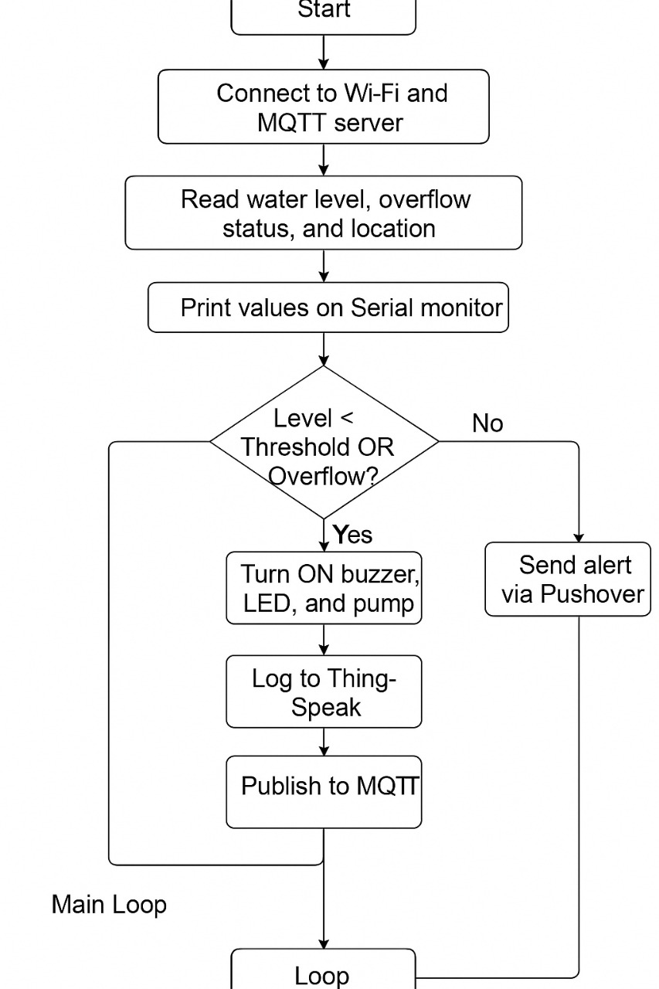

**CHAPTER 7**

**PROGRAM**

#include <WiFi.h>

#include <HTTPClient.h>

#include <PubSubClient.h>

#include <ArduinoJson.h>

// === WiFi Setup ===

const char* ssid = "********";

const char* password = "********";

// === Pushover Setup ===

String pushoverUserKey = "**********************";

String pushoverAPIKey = "******************";

// === ThingSpeak Setup ===

String thingSpeakApiKey = "************";

// === MQTT Setup ===

const char* mqttServer = "test.mosquitto.org";

const int mqttPort = 1883;

const char* mqttTopic = "flood/alert/system";

WiFiClient espClient;

PubSubClient mqttClient(espClient);

// === Pins ===

const int trigPin = 5;

const int echoPin = 18;

const int floatSensorPin = 19;

const int buzzer = 21;

const int led = 22;

const int pump = 23;

// === Threshold ===

const float waterThreshold = 50.0;

void setup() {

  Serial.begin(115200);

  pinMode(trigPin, OUTPUT);

  pinMode(echoPin, INPUT);

  pinMode(floatSensorPin, INPUT_PULLUP);

  pinMode(buzzer, OUTPUT);

  pinMode(led, OUTPUT);

  pinMode(pump, OUTPUT);

  WiFi.begin(ssid, password);

  while (WiFi.status() != WL_CONNECTED) delay(500);

  mqttClient.setServer(mqttServer, mqttPort);

  while (!mqttClient.connected()) mqttClient.connect("ESP32Client");

  Serial.println("Setup Complete");

}

void loop() {

  float level = getWaterLevel();

  bool overflow = digitalRead(floatSensorPin) == LOW;

  String location = getLocationByIP();

  // === Serial Monitor Output ===

  Serial.println("Water Level: " + String(level, 2) + " cm");

  Serial.println("Overflow: " + String(overflow ? "YES" : "NO"));

  Serial.println("Location: " + location);

  Serial.println("--------------------------------------------");

  logToThingSpeak(level, overflow, location);

  sendMQTT(level, overflow, location);

  // === ALERT CONDITION ===

  if (level < waterThreshold || overflow) {

    alert(location, level, overflow);

  } else {

    digitalWrite(buzzer, LOW);

    digitalWrite(led, LOW);

    digitalWrite(pump, LOW);

  }

  delay(15000);  // 15 seconds delay

}

// === Water Level Measurement ===

float getWaterLevel() {

  digitalWrite(trigPin, LOW); delayMicroseconds(2);

  digitalWrite(trigPin, HIGH); delayMicroseconds(10);

  digitalWrite(trigPin, LOW);

  long duration = pulseIn(echoPin, HIGH);

  return (duration * 0.0343) / 2;

}

// === Get Location using ipinfo.io ===

String getLocationByIP() {

  HTTPClient http;

  http.begin("http://ipinfo.io/json");

  int httpCode = http.GET();

  String location = "Unknown Location";

  if (httpCode == 200) {

    String payload = http.getString();

    DynamicJsonDocument doc(1024);

    deserializeJson(doc, payload);

    String city = doc["city"];

    String region = doc["region"];

    String country = doc["country"];

    location = city + ", " + region + ", " + country;

  }

  http.end();

  return location;

}

// === Log to ThingSpeak ===

void logToThingSpeak(float level, bool overflow, String location) {

  HTTPClient http;

  String url = "http://api.thingspeak.com/update?api_key=" + thingSpeakApiKey +

               "&field1=" + String(level) +

               "&field2=" + String(overflow) +

               "&field3=" + location;

  http.begin(url);

  http.GET();

  http.end();

}

// === MQTT Publish ===

void sendMQTT(float level, bool overflow, String location) {

  if (!mqttClient.connected()) mqttClient.connect("ESP32Client");

  String message = "Flood Alert System\nWater Level: " + String(level, 2) +

                   " cm\nOverflow: " + (overflow ? "YES" : "NO") +

                   "\nLocation: " + location;

  mqttClient.publish(mqttTopic, message.c_str());

}

// === Send Alert ===

void alert(String location, float level, bool overflow) {

  digitalWrite(buzzer, HIGH);

  digitalWrite(led, HIGH);

  digitalWrite(pump, HIGH);

  delay(3000);  // Buzzer ON for 3 seconds

  digitalWrite(buzzer, LOW); // Turn off buzzer

  HTTPClient http;

  String msg = "🚨 Flood Alert System\nWater Level: " + String(level, 2) +

               " cm\nOverflow: " + (overflow ? "YES" : "NO") +

               "\nLocation: " + location;

  String url = "https://api.pushover.net/1/messages.json";

  String postData = "token=" + pushoverAPIKey +

                    "&user=" + pushoverUserKey +

                    "&message=" + msg;

  http.begin(url);

  http.addHeader("Content-Type", "application/x-www-form-urlencoded");

  http.POST(postData);

  http.end();

}

**CHAPTER 8**

**OUTPUT**

1. **Setup of Project:**

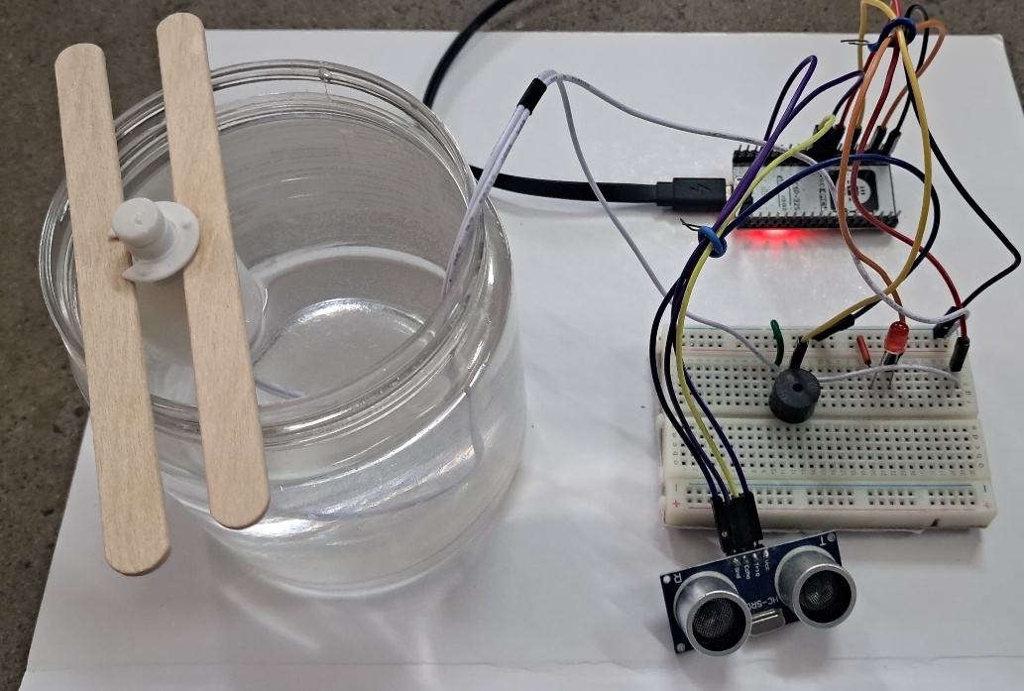

1. **Alert Trigger Example:**

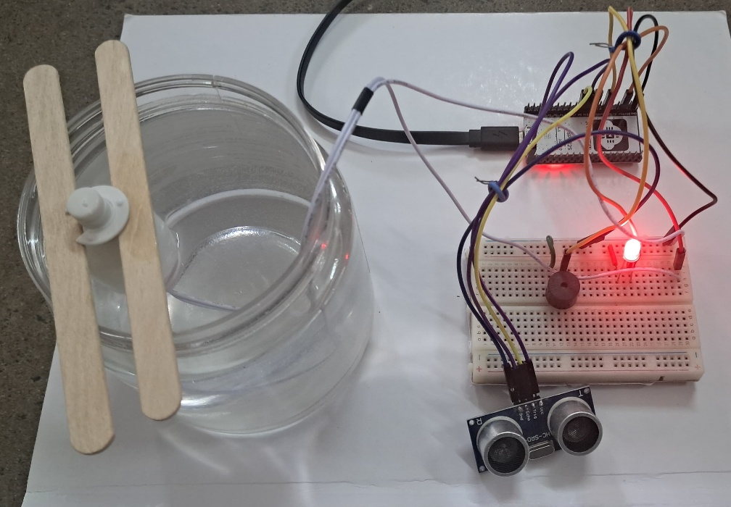

1. **Serial Monitor Output:**

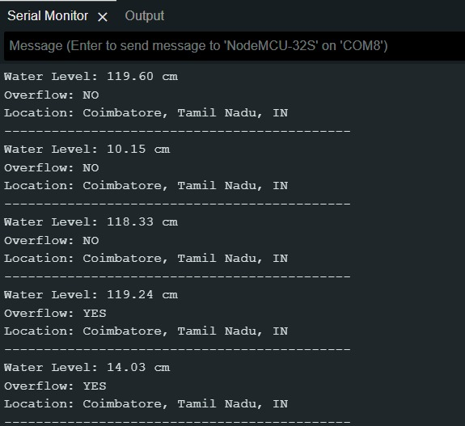

1. **Mobile Push Notification via Pushover:**

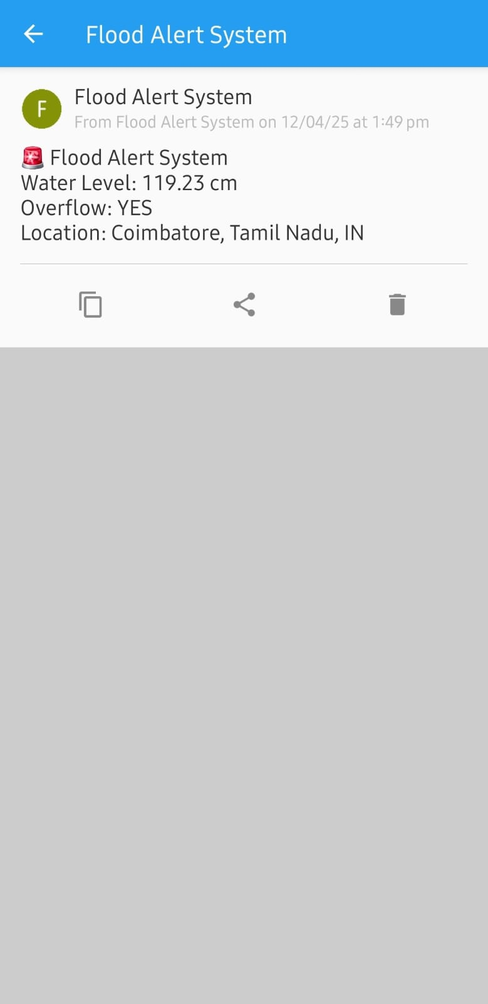

1. 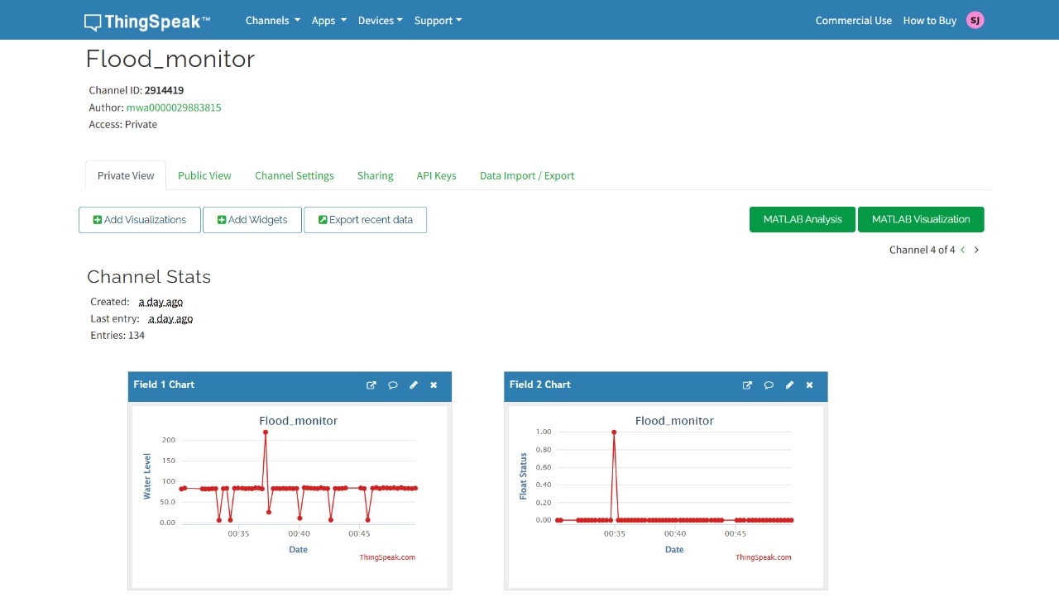**Real-Time Visualization Using ThingSpeak Dashboard:**
2. **MQTT Message Published:**

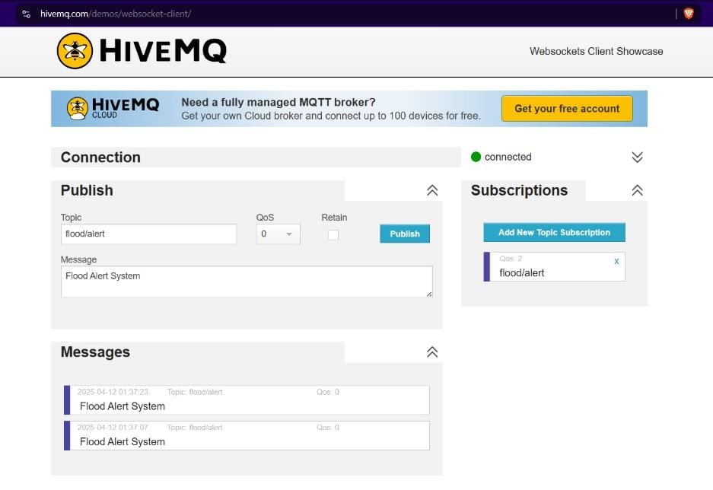

**CHAPTER 9**

**CONCLUSION**

The Advanced Flood Alert and Monitoring System Using IoT for Real-Time Disaster Management marks a significant milestone in the integration of modern technology with disaster risk mitigation strategies. The growing threat of climate change and erratic weather patterns has made flood prediction and management more critical than ever before. Traditional flood warning systems are often slow, require manual intervention, and may not provide real-time updates, especially in remote or vulnerable areas. The implementation of an IoT-based solution brings a paradigm shift in how flood situations can be monitored, analyzed, and responded to effectively.

This project leverages the power of embedded systems, wireless communication, and cloud-based data processing to create a highly responsive flood alert system. At the core of the system is the ESP32 microcontroller, chosen for its reliable performance, low power consumption, and built-in Wi-Fi capability. The system continuously monitors water levels using an ultrasonic sensor, and a float sensor is used as a redundancy for overflow detection. These sensors provide real-time data, which is crucial for predicting potential flooding events before they cause significant damage. The values are processed onboard and compared against predefined thresholds to trigger alerts.

One of the standout features of this system is its real-time communication and data sharing capabilities. The project uses ThingSpeak, a popular IoT analytics platform, to log sensor data and visualize water level trends over time. This provides not only real-time monitoring but also historical analysis that can help in understanding seasonal patterns or improving future flood prediction algorithms. Additionally, the system uses the MQTT protocol to publish live sensor data to a public broker, allowing external systems, applications, or even other nodes in a larger network to subscribe and respond accordingly. MQTT, being lightweight and efficient, is ideal for IoT applications where bandwidth and power are limited.

Another critical aspect of the system is the alerting mechanism, which utilizes the Pushover notification API to send mobile alerts directly to users when danger is detected. These alerts are immediate, location-specific, and user-friendly, ensuring that even non-technical users can understand the severity of the situation and take action accordingly. Furthermore, the system activates local alarms, such as a buzzer and LED, and even a water pump, enabling automatic responses that can be critical during emergencies, especially in areas where immediate manual intervention may not be possible.

In terms of versatility and adaptability, the system demonstrates how an IoT-based approach can be easily scaled and tailored to fit a variety of applications. For instance, in rural or semi-urban flood-prone zones, such a system can be solar-powered and remotely managed. In urban areas, it can be integrated into existing smart city frameworks to interact with broader environmental management systems. The modularity of the code and hardware also allows future enhancements, such as incorporating GSM modules for SMS-based alerts in areas with poor internet connectivity, or using machine learning algorithms to forecast flood risks based on real-time and historical data.

From an educational perspective, this project is an excellent example of the practical application of various engineering domains—embedded systems, IoT communication protocols, cloud computing, sensor networks, and disaster management strategies. It also highlights the importance of interdisciplinary knowledge, combining electronics, software development, and environmental science to solve real-world problems. Through this project, we learn how low-cost, readily available components can be transformed into life-saving solutions when integrated thoughtfully.

Moreover, the system addresses not only the technological challenges but also the social and humanitarian aspects of disaster management. By enabling early warnings and encouraging proactive measures, the system helps reduce panic, streamline evacuations, and potentially save lives. Timely alerts allow communities and authorities to act swiftly, deploy resources more effectively, and minimize both human and economic losses. This democratization of technology ensures that even the most resource-constrained regions can benefit from smart solutions.

In conclusion, the Advanced Flood Alert and Monitoring System Using IoT represents a forward-thinking approach to disaster preparedness and real-time environmental monitoring. It bridges the gap between real-world problems and smart solutions by utilizing affordable, efficient, and scalable technology. As floods continue to be a pressing global challenge, such innovations are not just optional—they are essential. This system serves as a prototype for future smart environmental monitoring solutions, and with further research and development, it can be transformed into a fully deployable product capable of protecting communities worldwide from the devastating effects of floods.